Equipment Required.

1) PC with USB and AVR Studio installed
2) AVR Pod

IMPORTANT - WHEN INSTALLING AVR Studio ON THE PC, DO NOT CONNECT THE AVR POD AND USB CABLE TO THE PC UNTIL AVR STUDIO INSTALLATION IS COMPLETED.

Programming Procedure
1) Connect the AVR pod to the 6-pin header (J16) on the pwb, note red band on ribbon cable is pin 1. The status led on the AVR pod should be green.

2) Run AVRStudio and Connect to the pod by pressing the
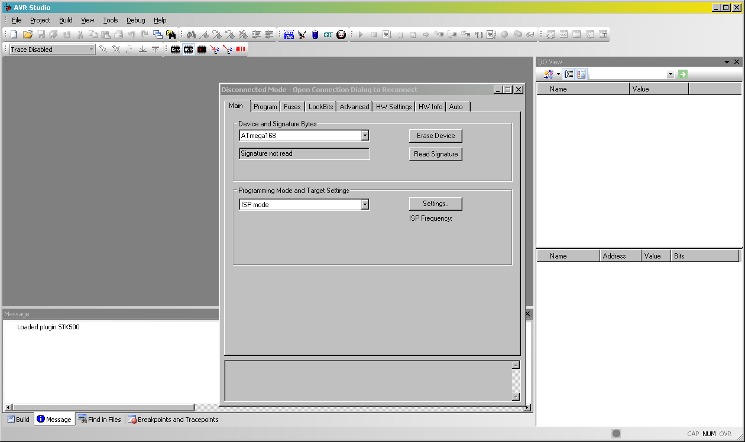
button. If prompted select AVRISP mkII on USB port. When the pod connects you will see the following screen in step 3.

3) Select the "Main" tab and use the dropdown to select "ATmega128". Press "Read Signature" and verify read signature matches selected device.

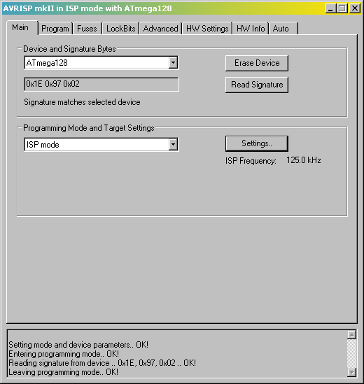

4) Press "Settings" button and select ISP frequency of 500kHz from drop down. Press "Write" button.

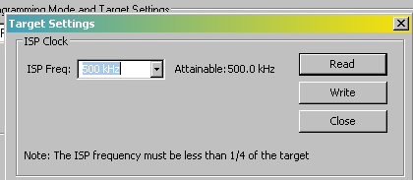

5) Select the Program Tab. In the Flash Section press the "....." button and browse to select the appropriate .hex file. Press "Program" in the flash section. The status LED on the AVR pod will be amber during programming.

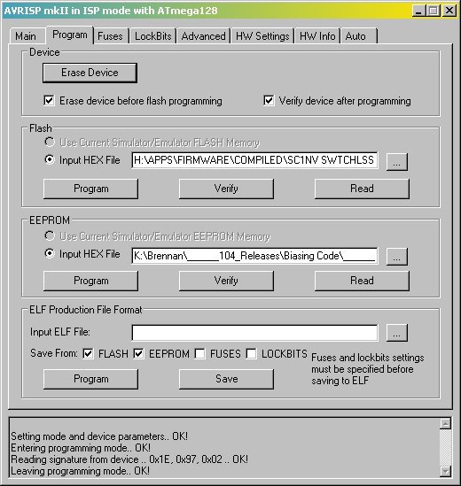

6) Note the dialog in the bottom of the window that will show programming status. If an error occurs, there will be a pop-up. If no pop-ups appear, and a "Leaving Programming Mode" ok message appears, then programming is complete. The status LED on the AVR pod will be green. Remove the AVR pod and return the board to service.

