Token replacement in 4.43.7 Gen 2 importer

1. Tokens installed in a 4.4.7 importer for Artist Experience data services before 2015 need to be replaced due to the original tokens have expired. To replace them: On the importer desktop, double click the Webadmin application to open Webadmin. Once open login to the application. The default username and password are admin, admin. Click submit. This will log into the application.

1. Once open, move cursor to the Administrator tab on the main menu screen of Webadmin. Click on Administrator.

1. After clicking on the Administrator tab, move cursor to the Services submenu tab. Click on Services.

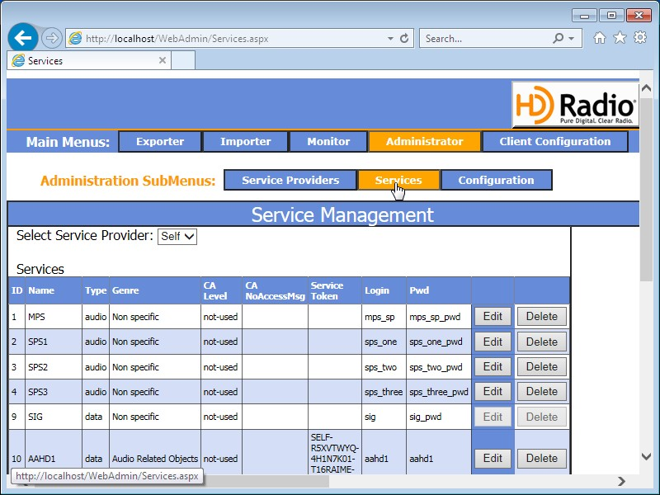

1. Once the services tab is open, this will display all audio and data services that are installed and configured in the importer. Scroll down until you start seeing data services that are labeled as Audio related Objects. These are the AE services that need to be edited. Move cursor to the first data service (usually named aad0, AlbumArt1, or AAHD1), click on the edit button next to that first service.

It should be noted here. There are two different services here: One for artist experience of the HD channel and the Station Logo for the HD channel. From the spreadsheet, make sure you install the correct token for the correct service. Station logo services will typically be named either ad0, StationLogo1, or SLHD1. Make sure from the Excel file or text file that the correct token is installed for the correct service. i.e. Album art1 will be for aad0, AlbumArt1, or AAHD1. Station-Logo1 will be for ad0, StationLogo1 or SLHD1). Follow this convention for the HD2, 3 and 4 channels if applicable.

1. Once the token is deleted, copy the new token from either the text file or Excel spreadsheet, and paste this new token in place of the old one.

1. Once the paste is complete, move cursor to the Update button on the right-hand side of the service being edited. Click Update. Once completed a message will appear indicating that the edit was successful.

1. Once complete repeat the procedure for all associated data services, as all of the tokens have expired. Once successfully completed, close the Webadmin application. Once closed, open the importer control panel. Move cursor to main menu bar and click on the stop sign to stop the importer. Once stopped, click on the green “running man” icon to start the importer. Once started, this completes the token update.

